INTRODUCTION
One of the major concerns in electricity industry today is power quality problems to sensitive loads. Presently, the majority of power quality problems are due to different fault conditions. These conditions cause voltage sag. Voltage sag may cause the apparatus tripping, shutdown commercial, domestic and industrial equipment, and miss process of drive system. The proposed system can provide the cost effective solution to mitigate voltage sag by establishing the appropriate voltage quality level, required by the customer. It is recently being used as the active solution Distributed Generation is a back-up electric power generating unit that is used in many industrial facilities, hospitals, campuses, commercial buildings and department stores. Most of these back-up units are used primarily by customers to provide emergency power during times when grid-connected power is unavailable and they are installed within the consumer premises where the electric demand is needed. The installation of the back-up units close to the demand center avoids the cost of transmitting the power and any associated transmission losses. Back-up generating units are currently defined as distributed generation to differentiate from the traditional centralized power generation model. The centralized power generation model has proven to be economical and a reliable source of energy production. However, with the lack of significant increase in building new generating capacity or even in expanding existing ones to meet the needs of today’s mega cities’ demand, the whole electrical power industry is facing serious challenges and is looking for a solution. The technological advancements have proven a path to the modern industries to extract and develop the innovative technologies within the limits of their industries for the fulfillment of their industrial goals. And their ultimate objective is to optimize the production while minimizing the production cost and thereby achieving maximized profits while ensuring continuous production throughout the period. As such a stable supply of un-interruptible power has to be guaranteed during the production process. The reason for demanding high quality power is basically the modern manufacturing and process equipment, which operates at high efficiency, requires high quality defect free power supply for the successful operation of their machines. More precisely most of those machine components are designed to be very sensitive for the power supply variations. Adjustable speed drives, automation devices, power electronic components are examples for such equipments. Failure to provide the required quality power output may sometimes cause complete shutdown of the industries which will make a major financial loss to the industry concerned .Thus the industries always demands for high quality power from the supplier or the utility. But the blame due to degraded quality cannot be solely put on to the hands of the utility itself .It has been found out most of the conditions that can disrupt the processes are generated within the industry itself. For example, most of the non-linear loads within the industries cause transients which can affect the reliability of the power supply.

RENEWABLE ENERGY RESOURCES
2.1 Introduction
A natural resource qualifies as a renewable resource if its stock (quantity) can increase over time. Natural resources which qualify as renewable resources are, for example, oxygen, fresh water, solar energy, timber, and biomass. But they can become non-renewable resources if more of them is used than nature can reproduce in the same time at that place. For example ground water may be removed from an aquifer at a greater rate than that of new water flowing to that aquifer. Removal of water from the pore spaces may cause permanent compaction (subsidence) that cannot be reversed. Human consumption and use at sustainable levels primarily uses renewable resources versus non-renewable resources.
2.2. Difference between Renewable and non-renewable Resources
2.2.1 Renewable Energy
Renewable energy is energy which is generated from natural sources i.e. sun, wind, rain, tides and can be generated again and again as and when required. They are available in plenty and by far most the cleanest sources of energy available on this planet. For e.g: Energy that we receive from the sun can be used to generate electricity. Similarly, energy from wind, geothermal, biomass from plants, tides can be used this form of energy to another form.
Here are some of the advantages and disadvantages of using renewable sources of energy:-
Advantages:
- The sun, wind, geothermal, ocean energy are available in the abundant quantity and free to use.
- The non-renewable sources of energy that we are using are limited and are bound to expire one day.
- Renewable sources have low carbon emissions, therefore they are considered as green and environment friendly.
- Renewable helps in stimulating the economy and creating job opportunities. The money that is used to build these plants can provide jobs to thousands to lakhs of people.
- You don't have to rely on any third country for the supply of renewable sources as in case of non-renewable sources.
- Renewable sources can cost less than consuming the local electrical supply. In the long run, the prices of electricity are expected to soar since they are based on the prices of crude oil, so renewable sources can cut your electricity bills.
- Various tax incentives in the form of tax waivers, credit deductions are available for individuals and businesses who want to go green.
Disadvantages:
- It is not easy to set up a plant as the initial costs are quite steep.
- Solar energy can be used during the day time and not during night or rainy season.
- Geothermal energy which can be used to generate electricity has side effects too. It can bring toxic chemicals beneath the earth surface onto the top and can create environmental changes.
- Hydroelectric provide pure form of energy but building dams across the river which is quite expensive can affect natural flow and affect wildlife.
- To use wind energy, you have to rely on strong winds therefore you have to choose suitable site to operate them. Also, they can affect bird population as they are quite high.

2.2.2 Non-renewable energy
Renewable energy is energy which is taken from the sources that are available on the earth in limited quantity and will vanish fifty-sixty years from now. Non-renewable sources are not environmental friendly and can have serious affect on our health. They are called non-renewable because they can be re-generated within a short span of time. Non-renewable sources exist in the form of fossil fuels, natural gas, oil and coal.
Here are some of the advantages and disadvantages of using non-renewable sources of energy:-
Advantages:
- Non-renewable sources are cheap and easy to use. You can easily fill up your car tank and power your motor vehicle.
- You can use small amount of nuclear energy to produce large amount of power.
- Non-renewable have little or no competition at all. For eg: if you are driving a battery driven car your battery gets discharged then you won't be able to charge it in the middle if the road rather it is easy to find a gas pumping station.
- They are considered as cheap when converting from one type of energy to another.
Disadvantage:
- Non-renewable sources will expire some day and we have to us our endangered resources to create more non-renewable sources of energy.
- The speed at which such resources are being utilized can have serious environmental changes.

WIND ENERGY
3.1 Introduction
Wind energy is nothing but the velocity by which the air flows. It is of kinetic energy; now days we are using wind mills to generate electrical power. A windmill is a machine which converts the energy of wind into rotational energy by means of vanes called sails or blades. Originally windmills were developed for milling grain for food production. In the course of history the windmill was adapted to many other industrial uses. An important application was to pump water. Windmills used for generating electricity are commonly known as wind turbines.
3.2 Need of Wind Mills In Present Generation
The development of wind power in India began in the 1990s, and has significantly increased in the last few years. Although a relative newcomer to the wind industry compared with Denmark or the US, India has the fifth largest installed wind power capacity in the world. In 2009-10 India's growth rate was highest among the other top four countries.
The worldwide installed capacity of wind power reached 197 GW by the end of 2010. China (44,733 MW), US (40,180 MW), Germany (27,215 MW) and Spain (20,676 MW) are ahead of India in fifth position. The short gestation periods for installing wind turbines, and the increasing reliability and performance of wind energy machines has made wind power a favored choice for capacity addition in India.
Suzlon, as Indian-owned Company, emerged on the global scene in the past decade, and by 2006 had captured almost 7.7 percent of market share in global wind turbine sales. Suzlon is currently the leading manufacturer of wind turbines for the Indian market, holding some 52 percent of market share in India. Suzlon’s success has made India the developing country leader in advanced wind turbine technology

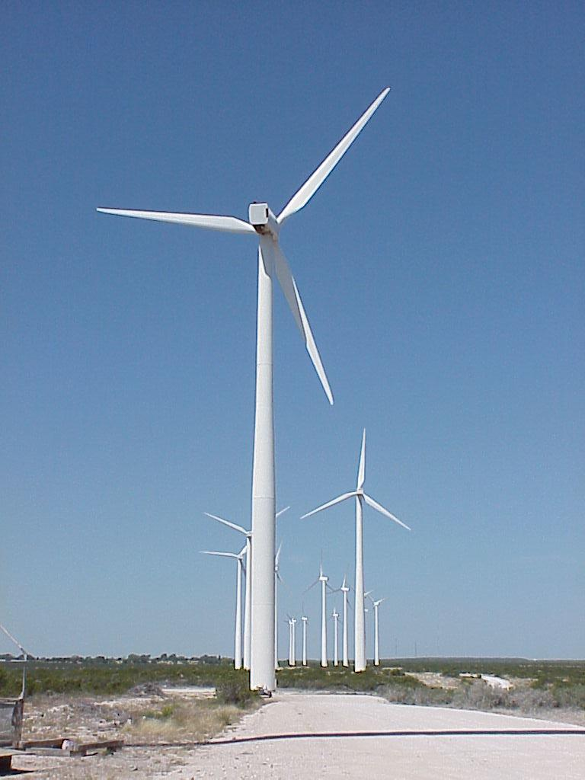
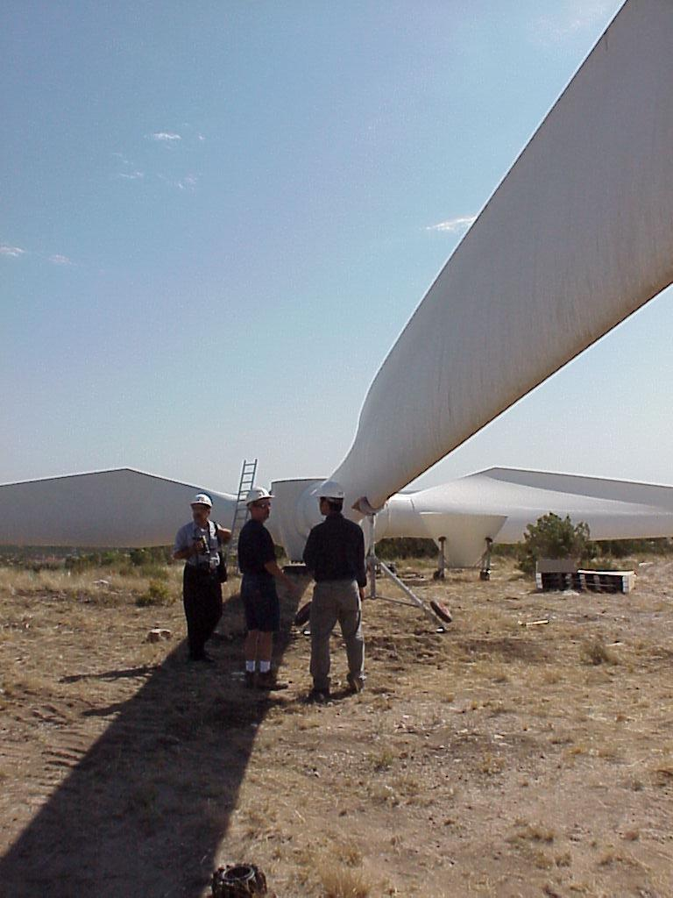
Fig: 3.1(a) Fig: 3.1(b)

Fig 3.1(a ,b) Generation of wind energy

FUEL CELLS

4.1 Introduction
A fuel cell is an electrochemical cell that converts a source fuel into an electrical current. It generates electricity inside a cell through reactions between a fuel and an oxidant, triggered in the presence of an electrolyte. The reactants flow into the cell, and the reaction products flow out of it, while the electrolyte remains within it. Fuel cells can operate continuously as long as the necessary reactant and oxidant flows are maintained.
Fuel cells are different from conventional electrochemical cell batteries in that they consume reactant from an external source, which must be replenished^{[1]} – a thermodynamically open system. By contrast, batteries store electrical energy chemically and hence represent a thermodynamically closed system.
Many combinations of fuels and oxidants are possible. A hydrogen fuel cell uses hydrogen as its fuel and oxygen (usually from air) as its oxidant. Other fuels include hydrocarbons and alcohols. Other oxidants include chlorine and chlorine dioxide
Fuel cells come in many varieties; however, they all work in the same general manner. They are made up of three segments which are sandwiched together: the anode, the electrolyte, and the cathode. Two chemical reactions occur at the interfaces of the three different segments. The net result of the two reactions is that fuel is consumed, water or carbon dioxide is created, and an electrical current is created, which can be used to power electrical devices, normally referred to as the load.
At the anode a catalyst oxidizes the fuel, usually hydrogen, turning the fuel into a positively charged ion and a negatively charged electron. The electrolyte is a substance specifically designed so ions can pass through it, but the electrons cannot. The freed electrons travel through a wire creating the electrical current. The ions travel through the electrolyte to the cathode. Once reaching the cathode, the ions are reunited with the electrons and the two react with a third chemical, usually oxygen, to create water or carbon dioxide.
4.2 Design Features In a Fuel
- The electrolyte substance. The electrolyte substance usually defines the type of fuel cell.
- The fuel that is used. The most common fuel is hydrogen.
- The anode catalyst, which breaks down the fuel into electrons and ions. The anode catalyst is usually made up of very fine platinum powder.
- The cathode catalyst, which turns the ions into the waste chemicals like water or carbon dioxide. The cathode catalyst is often made up of nickel.
A typical fuel cell produces a voltage from 0.6 V to 0.7 V at full rated load. Voltage decreases as current increases, due to several factors:
- Activation loss
- Ohmic loss (voltage drop due to resistance of the cell components and interconnects)
- Mass transport loss (depletion of reactants at catalyst sites under high loads, causing rapid loss of voltage).
To deliver the desired amount of energy, the fuel cells can be combined in series and parallel circuits, where series yields higher voltage, and parallel allows a higher current to be supplied. Such a design is called a fuel cell stack. The cell surface area can be increased, to allow stronger current from each cell.
4.3 Types of Fuel Cells

4.3.1 Proton Exchange Fuel Cells
In the archetypal hydrogen–oxygen proton exchange membrane fuel cell (PEMFC) design, a proton-conducting polymer membrane, (the electrolyte), separates the anode and cathode sides. This was called a "solid polymer electrolyte fuel cell" (SPEFC) in the early 1970s, before the proton exchange mechanism was well-understood. (Notice that "polymer electrolyte membrane" and "proton exchange mechanism" result in the same acronym.)
On the anode side, hydrogen diffuses to the anode catalyst where it later dissociates into protons and electrons. These protons often react with oxidants causing them to become what is commonly referred to as multi-facilitated proton membranes. The protons are conducted through the membrane to the cathode, but the electrons are forced to travel in an external circuit (supplying power) because the membrane is electrically insulating. On the cathode catalyst, oxygen molecules react with the electrons (which have traveled through the external circuit) and protons to form water.
4.3.2 Proton Exchange Membrane Fuel Cell Design Issues
Costs In 2002, typical fuel cell systems cost US$1000 per kilowatt of electric power output. In 2009, the Department of Energy reported that 80-kW automotive fuel cell system costs in volume production (projected to 500,000 units per year) are $61 per kilowatt. The goal is $35 per kilowatt. In 2008 UTC Power has 400 kW stationary fuel cells for $1,000,000 per 400 kW installed costs. The goal is to reduce the cost in order to compete with current market technologies including gasoline internal combustion engines. Many companies are working on techniques to reduce cost in a variety of ways including reducing the amount of platinum needed in each individual cell. Ballard Power Systems have experiments with a catalyst enhanced with carbon silk which allows a 30% reduction (1 mg/cm² to 0.7 mg/cm²) in platinum usage without reduction in performance. Monash University, Melbourne uses PEDOT as a cathode.
The production costs of the PEM (proton exchange membrane). The Nafion membrane currently costs $566/m². In 2005 Ballard Power Systems announced that its fuel cells will use Sholapur, a porous polyethylene film patented by DSM.
Water and air management (in PEMFCs). In this type of fuel cell, the membrane must be hydrated, requiring water to be evaporated at precisely the same rate that it is produced. If water is evaporated too quickly, the membrane dries, resistance across it increases, and eventually it will crack, creating a gas "short circuit" where hydrogen and oxygen combine directly, generating heat that will damage the fuel cell.
If the water is evaporated too slowly, the electrodes will flood, preventing the reactants from reaching the catalyst and stopping the reaction. Methods to manage water in cells are being developed like electro osmotic pumps focusing on flow control. Just as in a combustion engine, a steady ratio between the reactant and oxygen is necessary to keep the fuel cell operating efficiently.
4.3.3 High Temperature Fuel Cell
A solid oxide fuel cell (SOFC) is extremely advantageous “because of a possibility of using a wide variety of fuel” [. Unlike most other fuel cells which only use hdrogen, SOFCs can run on hydrogen, butane, methanol, and other petroleum products. The different fuels each have their own chemistry.
For methanol fuel cells, on the anode side, a catalyst breaks methanol and water down to form carbon dioxide, hydrogen ions, and free electrons. The hydrogen ions move across the electrolyte to the cathode side, where they react with oxygen to create water. A load connected externally between the anode and cathode completes the electrical circuit. Below are the chemical equations for the reaction:
Anode Reaction: CH₃OH + H₂O → CO₂ + 6H⁺ + 6e⁻
Cathode Reaction: 3/2 O₂ + 6H⁺ + 6e⁻ → 3H₂O
Overall Reaction: CH₃OH + 3/2 O₂ → CO₂ + 2H₂O + electrical energy
At the anode SOFCs can use nickel or other catalysts to break apart the methanol and create hydrogen ions and CO₂. A solid called yttrium stabilized zirconia (YSZ) is used as the electrolyte. Like all fuel cell electrolytes YSZ is conductive to ions, allowing them to pass from the anode to cathode, but is non-conductive to electrons. YSZ is a durable solid and is advantageous in large industrial systems. Although YSZ is a good ion conductor, it only works at very high temperatures.
4.4 Fuel Cell Efficiency
The efficiency of a fuel cell is dependent on the amount of power drawn from it. Drawing more power means drawing more current, which increases the losses in the fuel cell. As a general rule, the more power (current) drawn, the lower the efficiency. Most losses manifest themselves as a voltage drop in the cell, so the efficiency of a cell is almost proportional to its voltage. For this reason, it is common to show graphs of voltage versus current (so-called polarization curves) for fuel cells.
A typical cell running at 0.7 V has an efficiency of about 50%, meaning that 50% of the energy content of the hydrogen is converted into electrical energy; the remaining 50% will be converted into heat. (Depending on the fuel cell system design, some fuel might leave the system unreacted, constituting an additional loss.)
For a hydrogen cell operating at standard conditions with no reactant leaks, the efficiency is equal to the cell voltage divided by 1.48 V, based on the enthalpy, or heating value, of the reaction. For the same cell, the second law efficiency is equal to cell voltage divided by 1.23 V. (This voltage varies with fuel used, and quality and temperature of the cell.) The difference between these numbers represents the difference between the reaction's enthalpy and Gibbs free energy. This difference always appears as heat, along with any losses in electrical conversion efficiency.
Fuel cells do not operate on a thermal cycle. As such, they are not constrained, as combustion engines are, in the same way by thermodynamic limits, such as Carnot cycle efficiency. At times this is misrepresented by saying that fuel cells are exempt from the laws of thermodynamics, because most people think of thermodynamics in terms of combustion processes (enthalpy of formation). The laws of thermodynamics also hold for chemical processes (Gibbs free energy) like fuel cells, but the maximum theoretical efficiency is higher (83% efficient at 298K in the case of hydrogen/oxygen reaction) than the Otto cycle thermal efficiency (60% for compression ratio of 10 and specific heat ratio of 1.4).
Comparing limits imposed by thermodynamics is not a good predictor of practically achievable efficiencies. Also, if propulsion is the goal, electrical output of the fuel cell has to still be converted into mechanical power with another efficiency drop. In reference to the exemption claim, the correct claim is that the "limitations imposed by the second law of thermodynamics on the operation of fuel cells are much less severe than the limitations imposed on conventional energy conversion systems".^{[23]} Consequently, they can have very high efficiencies in converting chemical energy to electrical energy, especially when they are operated at low power density, and using pure hydrogen and oxygen as reactants.
It should be underlined that fuel cell (especially high temperature) can be used as a heat source in conventional heat engine (gas turbine system). In this case the ultra high efficiency is predicted (above 70%).

4.5 In Practice
For a fuel cell operating on air, losses due to the air supply system must also be taken into account. This refers to the pressurization of the air and dehumidifying it. This reduces the efficiency significantly and brings it near to that of a compression ignition engine. Furthermore, fuel cell efficiency decreases as load increases.
The tank-to-wheel efficiency of a fuel cell vehicle is greater than 45% at low loads and shows average values of about 36% when a driving cycle like the NEDC (New European Driving Cycle) is used as test procedure. The comparable NEDC value for a Diesel vehicle is 22%. In 2008 Honda released a fuel cell electric vehicle (the Honda FCX Clarity) with fuel stack claiming a 60% tank-to-wheel efficiency.
It is also important to take losses due to fuel production, transportation, and storage into account. Fuel cell vehicles running on compressed hydrogen may have a power-plant-to-wheel efficiency of 22% if the hydrogen is stored as high-pressure gas, and 17% if it is stored as liquid hydrogen.^{[29]} In addition to the production losses, over 70% of US' electricity used for hydrogen production comes from thermal power, which only has an efficiency of 33% to 48%, resulting in a net increase in carbon dioxide production by using hydrogen in vehicles[
Fuel cells cannot store energy like a battery, but in some applications, such as stand-alone power plants based on discontinuous sources such as solar or wind power, they are combined with electrolyzes and storage systems to form an energy storage system. The overall efficiency (electricity to hydrogen and back to electricity) of such plants (known as round-trip efficiency) is between 30 and 50%, depending on conditions.^{[30]} While a much cheaper lead-acid battery might return about 90%, the electrolyze/fuel cell system can store indefinite quantities of hydrogen, and is therefore better suited for long-term storage.
Solid-oxide fuel cells produce exothermic heat from the recombination of the oxygen and hydrogen. The ceramic can run as hot as 800 degrees Celsius. This heat can be captured and used to heat water in a micro combined heat and power (m-CHP) application. When the heat is captured, total efficiency can reach 80-90% at the unit, but does not consider production and distribution losses. CHP units are being developed today for the European home market.
Stationary fuel cell applications (or stationary fuel cell power systems) are stationary that are either connected to the electric grid (distributed generation) to provide supplemental power and as emergency power system for critical areas, or installed as a grid-independent generator for on-site service.
- Fuel cell gas appliances up to 70 kW
- Installation permitting guidance for hydrogen and fuel cells stationary applications
- Standard for the installation of stationary fuel cell power systems

4.5.1 Emergency Power Systems
Emergency power systems are a type fuel cell system, which may include lighting, generators and other apparatus, to provide backup resources in a crisis or when regular systems fail. They find uses in a wide variety of settings from residential homes to hospitals, scientific laboratories, data centers, telecommunication equipment and modern naval ships.

4.5.2 Uninterrupted Power supply
An uninterrupted power supply (UPS) provides emergency power and, depending on the topology, provide line regulation as well to connected equipment by supplying power from a separate source when utility power is not available. It differs from an auxiliary power supply or standby generator, which does not provide instant protection from a momentary power interruption.
4.6 Parts of Fuel Cell
The anode, which is the negative end of the fuel cell, has several functions. It conducts the electrons that are freed from the hydrogen molecules so that they can be used in an external circuit. It also has channels etched into it that disperse the hydrogen gas equally over the surface of the catalyst.
The cathode, which is the positive end of the fuel cell, has channels etched into it that distribute the oxygen to the surface of the catalyst. It also conducts the electrons back from the external circuit to the catalyst, where they can recombine with the hydrogen ions and oxygen to form water.
The electrolyte is the proton exchange membrane (PEM). It is specially treated material, which resembles plastic wrap that you use in your kitchen, only it conducts positively charged ions. The membrane blocks electrons.
The catalyst is a special material that facilitates the reaction of oxygen and hydrogen. It is made of platinum powder very thinly coated onto carbon paper or cloth. The catalyst is rough so that the maximum surface area of the platinum can be exposed to the hydrogen or oxygen. The platinum-coated side of the catalyst faces the PEM.
4.7 Fuel Cell Applications
- POWER
Fuel cells are very useful as power sources in remote locations, such as spacecraft, remote weather stations, large parks, rural locations, and in certain military applications. A fuel cell system running on hydrogen can be compact and lightweight, and have no major moving parts.
Because fuel cells have no moving parts and do not involve combustion, in ideal conditions they can achieve up to 99.9999% reliability. This equates to around one minute of down time in a two year period.
Since electrolyses systems do not store fuel in themselves, but rather rely on external storage units, they can be successfully applied in large-scale energy storage, rural areas being one example. In this application, batteries would have to be largely oversized to meet the storage demand, but fuel cells only need a larger storage unit (typically cheaper than an electrochemical device).
One such pilot program is operating on Stuart Island in Washington State. There the Stuart Island Energy Initiative has built a complete, closed-loop system: Solar panels power an electrolyzer which makes hydrogen. The hydrogen is stored in a 500 gallon tank at 200 PSI, and runs a Reli On fuel cell to provide full electric back-up to the off-the-grid residence.
- COGENERATION
Micro combined heat and power (MicroCHP) systems such as home fuel cells and cogeneration for office buildings and factories are in the mass production phase. The system generates constant electric power (selling excess power back to the grid when it is not consumed), and at the same time produces hot air and water from the waste heat. Micro CHP is usually less than 5 k We for a home fuel cell or small business.
A lower fuel-to-electricity conversion efficiency is tolerated (typically 15-20%), because most of the energy not converted into electricity is utilized as heat. Some heat is lost with the exhaust gas just as in a normal furnace, so the combined heat and power efficiency is still lower than 100%, typically around 80%. In terms of energy however, the process is inefficient, and one could do better by maximizing the electricity generated and then using the electricity to drive a heat pump. Phosphoric-acid fuel cells (PAFC) comprise the largest segment of existing CHP products worldwide and can provide combined efficiencies close to 90% (35-50% electric + remainder as thermal) Molten-carbonate fuel cells have also been installed in these applications, and solid-oxide fuel cell prototypes exist.
4.8 Other Applications
- Providing power for base stations or cell sites
- Off-grid power supply
- Distributed generation
- Fork Lifts
- Emergency power systems are a type of fuel cell system, which may include lighting, generators and other apparatus, to provide backup resources in a crisis or when regular systems fail. They find uses in a wide variety of settings from residential homes to hospitals, scientific laboratories, data centers, telecommunication equipment and modern naval ships.
- An uninterrupted power supply (UPS) provides emergency power and, depending on the topology, provide line regulation as well to connected equipment by supplying power from a separate source when utility power is not available. Unlike a standby generator, it can provide instant protection from a momentary power interruption.
- Base load power plants
- Electric and hybrid vehicles.
- Notebook computers for applications where AC charging may not be available for weeks at a time.
- Portable charging docks for small electronics (e.g. a belt clip that charges your cell phone or PDA).
- Smartphone with high power consumption due to large displays and additional features like GPS might be equipped with micro fuel cells.
- Small heating appliances.
4.9 Advantages
• Fuel cells eliminate pollution caused by burning fossil fuels; the only byproduct is water.
• If he hydrogen used comes from the electrolysis of water, then using fuel cells eliminates greenhouse gases.
• Fuel cells do not need conventional fuels such as oil or gas and can therefore eliminate economic dependence on politically unstable countries.
• Since hydrogen can be produced anywhere where there is water and electricity, production of potential fuel can be distributed.
• Installation of smaller stationary fuel cells leads to a more stabilised and decentralized power grid.
• Fuel cells have a higher efficiency than diesel or gas engines
• Most fuel cells operate silently, compared to internal combustion engines
• Low temperature fuel cells (PEM, DMFC) have low heat transmission which makes them ideal for military applications

4.10 Disadvantages
• Fuelling fuel cells is still a problem since the production, transportation, distribution and storage of hydrogen is difficult.
• Reforming hydrocarbons via reformer to produce hydrogen is technically challenging and not clearly environmentally friendly.
• The refueling and the starting time of fuel cell vehicles are longer and the driving range is shorter than in a “normal” car.
• Fuel cells are in general slightly bigger than comparable batteries or engines. However, the size of the units is decreasing.
• Fuel cells are currently expensive to produce, since most units are hand-made.
• Some fuel cells use expensive materials.
• The technology is not yet fully developed and few products are available.

SOLAR CELLS
5.1 Introduction

Solar cells (as the name implies) are designed to convert (at least a portion of) available light into electrical energy. They do this without the use of either chemical reactions or moving parts.

5.2 History of Solar Cells

The development of the solar cell stems from the work of the French physicist Antoine-César Becquerel in 1839. Becquerel discovered the photovoltaic effect while experimenting with a solid electrode in an electrolyte solution; he observed that voltage developed when light fell upon the electrode. About 50 years later, Charles Fritts constructed the first true solar cells using junctions formed by coating the semiconductor selenium with an ultrathin, nearly transparent layer of gold. Fritts's devices were very inefficient, transforming less than 1 percent of the absorbed light into electrical energy.
By 1927 another metal semiconductor-junction solar cell, in this case made of copper and the semiconductor copper oxide, had been demonstrated. By the 1930s both the selenium cell and the copper oxide cell were being employed in light-sensitive devices, such as photometers, for use in photography. These early solar cells, however, still had energy-conversion efficiencies of less than 1 percent. This impasse was finally overcome with the development of the silicon solar cell by Russell Ohl in 1941. In 1954, three other American researchers, G.L. Pearson, Daryl Chapin, and Calvin Fuller, demonstrated a silicon solar cell capable of a 6-percent energy-conversion efficiency when used in direct sunlight. By the late 1980s silicon cells, as well as those made of gallium arsenide, with efficiencies of more than 20 percent had been fabricated. In 1989 a concentrator solar cell, a type of device in which sunlight is concentrated onto the cell surface by means of lenses, achieved an efficiency of 37 percent due to the increased intensity of the collected energy. In general, solar cells of widely varying efficiencies and cost are now available.

5.3 Structure
Modern solar cells are based on semiconductor physics -- they are basically just P-N junction photodiodes with a very large light-sensitive area. The photo voltaiceffect, which causes the cell to convert light directly into electrical energy, occurs in the three energy-conversion layers .The structure shown in below fig 5.1
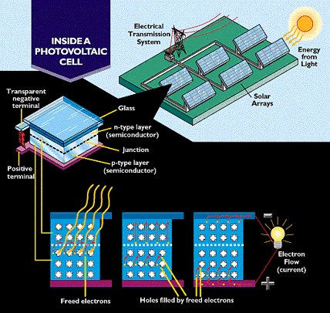
Fig 5.1 Solar cell module

The first of these three layers necessary for energy conversion in a solar cell is the top junction layer (made of N-type semiconductor ). The next layer in the structure is the core of the device; this is the absorber layer (the P-N junction). The last of the energy-conversion layers is the back junction layer (made of type semiconductor).
As may be seen in the above diagram, there are two additional layers that must be present in a solar cell. These are the electrical contact layers. There must obviously be two such layers to allow electric current to flow out of and into the cell. The electrical contact layer on the face of the cell where light enters is generally present in some grid pattern and is composed of a good conductor such as a metal.
The grid pattern does not cover the entire face of the cell since grid materials, though good electrical conductors, are generally not transparent to light. Hence, the grid pattern must be widely spaced to allow light to enter the solar cell but not to the extent that the electrical contact layer will have difficulty collecting the current produced by the cell. The back electrical contact layer has no such diametrically opposed restrictions. It need simply function as an electrical contact and thus covers the entire back surface of the cell structure. Because the back layer must be a very good electrical conductor, it is always made of metal.
5.4 Operation

Solar cells are characterized by a maximum Open Circuit Voltage (Voc) at zero output current and a Short Circuit Current (Isc) at zero output voltage. Since power can be computed via this equation:
P = I * V
Then with one term at zero these conditions (V = Voc / I = 0, V = 0 / I = Isc ) also represent zero power. As you might then expect, a combination of less than maximum current and voltage can be found that maximizes the power produced (called, not surprisingly, the "maximum power point"). Many BEAM designs (and, in particular, solar engines) attempt to stay at (or near) this point. The tricky part is building a design that can find the maximum power point regardless of lighting conditions.

5.5 Output Characteristics of Solar

The output characteristics of solar cells are expressed in the form of an I - V curve. An I - V curve test circuit and typical I - V curve produced by the circuit are shown below.
The I-V curve is produced by varying RL (load resistance) from zero to infinity and measuring the current and voltage along the way. The point at which the I-V curve and resistance (RL) intersect is the operating point of the solar cell. The current and voltage at this point are Ip and Vp, respectively. The largest operating point in the square area is the maximum output of the solar cell.
5.6 Applications
• Calculators
• Indoor clocks
• Remote control units
• Indoor digital thermometers
• Other indoor consumer products which have a low power consumption

5.7 Solar Power Advantages
- Solar energy is a completely renewable resource. This means that even when we cannot make use of the sun’s power because of nighttime or cloudy and stormy days, we can always rely on the sun showing up the very next day as a constant and consistent power source.
- Oil, which is what most people currently use to power their homes, is not a renewable resource. This means that as soon as the oil is gone, it is gone forever and we will no longer have power or energy.

5.8 Solar Power Disadvantages
- Solar power cannot be harnessed during a storm, on a cloudy day or at night. This limits how much power can be saved for future days. Some days you may still need to rely on oil to power your home.
- Solar power cannot be harnessed during a storm, on a cloudy day or at night. This limits how much power can be saved for future days. Some days you may still need to rely on oil to power your home.

5.9 Ultra Capacitors
An electric double-layer capacitor (EDLC), also known as super capacitor, super condenser, electrochemical double layer capacitor, or ultra capacitor, is an electrochemical capacitor with relatively high energy density. Compared to conventional electrolytic capacitors the energy density is typically on the order of hundreds of times greater. In comparison with conventional batteries or fuel cells, EDLCs also have a much higher power density. A typical D-cell sized electrolytic capacitor displays capacitance in the range of tens of milliards. The same size EDLC might reach several farads, an improvement of two orders of magnitude.
EDLCs usually yield a lower working voltage; as of 2010 larger double-layer capacitors have capacities up to 5,000 farads. Also in 2010, the highest available EDLC energy density is 30Wh/kg (0.1 MJ/kg) (although 85 Wh/kg has been achieved at room temperature in the lab^{[4]}), lower than rapid-charging lithium-titanate batteries

5.9.1 History
General Electric engineers experimenting with devices using porous carbon electrodes first observed the EDLC effect in 1957.^{[7]} They believed that the energy was stored in the carbon pores and the device exhibited "exceptionally high capacitance", although the mechanism was unknown at that time.
General Electric did not immediately follow up on this work. In 1966 researchers at Standard Oil of Ohio developed the modern version of the devices, after they accidentally re-discovered the effect while working on experimental fuel cell designs.^{[8]} Their cell design used two layers of activated charcoal separated by a thin porous insulator, and this basic mechanical design remains the basis of most electric double-layer capacitors.
`Standard Oil did not commercialize their invention, licensing the technology to NEC, who finally marketed the results as “super capacitors” in 1978, to provide backup power for maintaining computer memory.^{[8]} The market expanded slowly for a time, but starting around the mid-1990s various advances in materials science and refinement of the existing systems led to rapidly improving performance and an equally rapid reduction in cost.
The first trials of super capacitors in industrial applications were carried out for supporting the energy supply to robots. The fig shown in below diagram 5.2

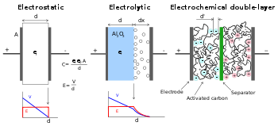
Fig 5.2 Ultra capacitor module

Comparison of construction diagrams of three capacitors. Left: "normal" capacitor, middle: electrolytic, right: electric double-layer capacitor
In a conventional capacitor, energy is stored by the removal of charge carriers, typically electrons, from one metal plate and depositing them on another. This charge separation creates a potential between the two plates, which can be harnessed in an external circuit. The total energy stored in this fashion increases with both the amount of charge stored and the potential between the plates. The amount of charge stored per unit voltages essentially a function of the size, the distance, and the material properties of the plates and the material in between the plates (the dielectric), while the potential between the plates is limited by the breakdown of the dielectric. The dielectric controls the capacitor's voltage. Optimizing the material leads to higher energy density for a given size of capacitor.
EDLCs do not have a conventional dielectric. Rather than two separate plates separated by an intervening insulator, these capacitors use virtual plates that are in fact two layers of the same substrate. Their electrochemical properties, the so-called "electrical double layer", result in the effective separation of charge despite the vanishingly thin (on the order of nanometers) physical separation of the layers. The lack of need for a bulky layer of dielectric, and the porosity of the material used, permits the packing of plates with much larger surface area into a given volume, resulting in high capacitances in practical-sized packages.
In an electrical double layer, each layer by itself is quite conductive, but the physics at the interface where the layers are effectively in contact means that no significant current can flow between the layers. However, the double layer can withstand only a low voltage, which means that electric double-layer capacitors rated for higher voltages must be made of matched series-connected individual EDLCs, much like series-connected cells in higher-voltage batteries.
EDLCs have much higher power density than batteries. Power density combines the energy density with the speed that the energy can be delivered to the load. Batteries, which are based on the movement of charge carriers in a liquid electrolyte, have ^{[6]} relatively slow charge and discharge times. Capacitors, on the other hand, can be charged or discharged at a rate that is typically limited by current heating of the electrodes.
So while existing EDLCs have energy densities that are perhaps 1/10 that of a conventional battery, their power density is generally 10 to 100 times as great. This makes them most suited to an intermediary role between electrochemical batteries and electrostatic capacitors, where neither sustained energy release nor immediate power demands dominate one another.
Super capacitors have several disadvantages and advantages relative to batteries, as described below.
5.9.2 Disadvantages

- The amount of energy stored per unit weight is generally lower than that of an electrochemical battery (3–5 W·h/kg for a standard ultra capacitor, although 85 W.h/kg has been achieved in the lab^{[4]} as of 2010 compared to 30-40 W·h/kg for a lead acid battery), 250-340 W·h/kg for a lithium-ion battery and about 1/1,000th the volumetric energy density of gasoline.
- Typical of any capacitor, the voltage varies with the energy stored. Effective storage and recovery of energy requires complex electronic control and switching equipment, with consequent energy loss
- Has the highest dielectric absorption of any type of capacitor.
- High self-discharge - the rate is considerably higher than that of an electrochemical battery.
- Cells hold low voltages - serial connections are needed to obtain higher voltages. Voltage balancing is required if capacitors are connected in series.
- Linear discharge voltage prevents use of the full energy spectrum.
- Very low internal resistance allows extremely rapid discharge when shorted, resulting in a shock hazard similar to any other capacitor of similar voltage and capacitance (generally much higher than electrochemical cells).

5.9.3 Advantages
- Low cost per cycle
- Good reversibility
- Very high rates of charge and discharge.
- Extremely low internal resistance (ESR) and consequent high cycle efficiency (95% or more) and extremely low heating levels
- High output power
- High specific power. According to ITS (Institute of Transportation Studies, Davis, California) test results, the specific power of electric double-layer capacitors can exceed 6 kW/kg at 95% efficiency^{[12]}
- Improved safety, no corrosive electrolyte and low toxicity of materials.
- Simple charge methods—no full-charge detection is needed; no danger of overcharging.

5.9.4 Applications

Heavy and public transport

Automotive

Consumer electronics
- Alternative energy

INTRODUCTION TO POWER ELECTRONICS
Power Electronics is a field which combines Power (electric power), Electronics and Control systems. Power engineering deals with the static and rotating power equipment for the generation, transmission and distribution of electric power. Electronics deals with the study of solid state semiconductor power devices and circuits for Power conversion to meet the desired control objectives (to control the output voltage and output power).
Power electronics may be defined as the subject of applications of solid state power semiconductor devices (Thyristors) for the control and conversion of electric power.
Power electronics deals with the study and design of Thyristorised power controllers for variety of application like Heat control, Light/Illumination control, Motor control – AC/DC motor drives used in industries, High voltage power supplies, Vehicle propulsion systems, High voltage direct current (HVDC) transmission.

6.1 Power Converters
A power converter is an electrical or electro-mechanical device for converting electrical energy. It may be converting AC to or from DC, or the voltage or frequency, or some combination of these.
Amongst the many devices that are used for this purpose are;
- Rectifier
- Inverter
- DC - DC converter
- AC - AC converter
- AC - DC Converter(Rectifier)
A rectifier is an electrical device that converts alternating current (AC), which periodically reverses direction, to direct current (DC), which is in only one direction, a process known as rectification.
Rectifiers have many uses including as components of power supplies and as detectors of radio signals. Rectifiers may be made of solid state diodes, vacuum tube diodes, mercury arc valves, and other components.
- DC - AC Converter(Inverter)
An inverter is an electrical device that converts direct current (DC) to alternating current (AC); the converted AC can be at any required voltage and frequency with the use of appropriate transformers, switching, and control circuits.
Solid-state inverters have no moving parts and are used in a wide range of applications, from small switching power supplies in computers, to large electric utility high-voltage direct current applications that transport bulk power. Inverters are commonly used to supply AC power from DC sources such as solar panels or batteries.

DC - DC Converter(Choppers)
A dc chopper is a dc-to-dc voltage converter. It is a static switching electrical appliance that in one Electrical conversion, changes an input fixed dc voltage to an adjustable dc output voltage without Inductive or capacitive intermediate energy storage. The name chopper is connected with the fact that the output voltage is a ‘chopped up’ quasi-rectangular version of the input dc voltage.

AC - AC Converter
An AC/AC converter converts an AC waveform such as the mains supply, to another AC waveform, where the output voltage and frequency can be set arbitrarily.
AC/AC converters can be categorized into
- Cycloconverters
- Matrix Converte
6.2 Power Electronic Switches

Diodes
Diodes were the first semiconductor electronic devices. The discovery of crystals' rectifying abilities was made by German physicist Ferdinand Braun in 1874. The first semiconductor diodes, called cat's whisker diodes, developed around 1906, were made of mineral crystals such as galena. Today most diodes are made of silicon, but other semiconductors such as germanium are sometimes used.
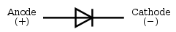
Fig 6.1 Diode
A modern semiconductor diode is made of a crystal of semiconductor like silicon that has impurities added to it to create a region on one side that contains negative charge carriers (electrons), called n-type semiconductor, and a region on the other side that contains positive charge carriers (holes), called p-type semiconductor. The diode's terminals are attached to each of these regions. The boundary within the crystal between these two regions, called a PN junction, is where the action of the diode takes place. The crystal conducts a current of electrons in a direction from the N-type side (called the cathode) to the P-type side (called the anode), but not in the opposite direction. However, conventional current flows from anode to cathode in the direction of the arrow (opposite to the electron flow, since electrons have negative charge).
Another type of semiconductor diode, the Scotty diode, is formed from the contact between a metal and a semiconductor rather than by a p–n junction.

Thyristers
A thyristor is a solid-state semiconductor device with four layers of alternating n and p-type material. They act as bistable switches, conducting when their gate receives a current pulse, and continue to conduct while they are forward biased (that is, while the voltage across the device is not reversed).
Some sources define silicon controlled rectifiers and thyristors as synonymous.
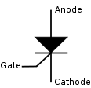
Fig 6.2 Circuit symbol for a Thyristor

Function
The thyristor is a four-layer, three terminal semiconducting device, with each layer consisting of alternately N-type or P-type material, for example P-N-P-N. The main terminals, labeled anode and cathode, are across the full four layers, and the control terminal, called the gate, is attached to p-type material near to the cathode. (A variant called an SCS—Silicon Controlled Switch—brings all four layers out to terminals.) The operation of a thyristor can be understood in terms of a pair of tightly coupled bipolar junction transistors, arranged to cause the self-latching action.
Thyristors have three states
- Reverse blocking mode — Voltage is applied in the direction that would be blocked by a diode
- Forward blocking mode — Voltage is applied in the direction that would cause a diode to conduct, but the thyristor has not yet been triggered into conduction
- Forward conducting mode — The thyristor has been triggered into conduction and will remain conducting until the forward current drops below a threshold value known as the "holding current"

Insulated Bipolar Transistor (IGBTS)
The insulated-gate bipolar transistor or IGBT is a three-terminal power semiconductor device, noted for high efficiency and fast switching. It switches electric power in many modern appliances: electric cars, variable speed refrigerators, air-conditioners, and even stereo systems with digital amplifiers. Since it is designed to rapidly turn on and off, amplifiers that use it often synthesize complex waveforms with pulse width modulation and low-pass filters.
The IGBT combines the simple gate-drive characteristics of the MOSFETs with the high-current and low–saturation-voltage capability of bipolar transistors by combining an isolated-gate FET for the control input, and a bipolar power transistor as a switch, in a single device. The IGBT is used in medium- to high-power applications such as switched-mode power supply, traction motor control and induction heating. Large IGBT modules typically consist of many devices in parallel and can have very high current handling capabilities in the order of hundreds of amps with blocking voltages of 6,000 V.
MOSFET
The metal–oxide–semiconductor field-effect transistor (MOSFET, MOS-FET, or MOS FET) is a transistor used for amplifying or switching electronic signals. The basic principle of this kind of transistor was first proposed by Julius Edgar Lilienfeld in 1925. In MOSFETs, a voltage on the oxide-insulated gate electrode can induce a conducting channel between the two other contacts called source and drain. The channel can be of n-type or p-type (see article on semiconductor devices), and is accordingly called an nMOSFET or a pMOSFET (also commonly nMOS, pMOS). It is by far the most common transistor in both digital and analog circuits, though the bipolar junction transistor was at one time much more common.
The 'metal' in the name is now often a misnomer because the previously metal gate material is now often a layer of polysilicon (polycrystalline silicon). Aluminium had been the gate material until the mid 1970s, when polysilicon became dominant, due to its capability to form self-aligned gates. Metallic gates are regaining popularity, since it is difficult to increase the speed of operation of transistors without metal gates.
MOSFET Operation
A metal–oxide–semiconductor field-effect transistor (MOSFET) is based on the modulation of charge concentration by a MOS capacitance between a body electrode and a gate electrode located above the body and insulated from all other device regions by a gate dielectric layer which in the case of a MOSFET is an oxide, such as silicon dioxide. If dielectrics other than an oxide such as silicon dioxide (often referred to as oxide) are employed the device may be referred to as a metal–insulator–semiconductor FET (MISFET). Compared to the MOS capacitor, the MOSFET includes two additional terminals (source and drain), each connected to individual highly doped regions that are separated by the body region. These regions can be either p or n type, but they must both be of the same type, and of opposite type to the body region. The source and drain (unlike the body) are highly doped as signified by a '+' sign after the type of doping.
If the MOSFET is an n-channel or nMOS FET, then the source and drain are 'n+' regions and the body is a 'p' region. As described above, with sufficient gate voltage, holes from the body are driven away from the gate, forming an inversion layer or n-channel at the interface between the p region and the oxide. This conducting channel extends between the source and the drain, and current is conducted through it when a voltage is applied between source and drain. Increasing the voltage on the gate leads to a higher electron density in the inversion layer and therefore increases the current flow between the source and drain.
For gate voltages below the threshold value, the channel is lightly populated, and only a very small sub threshold leakage current can flow between the source and the drain.
If the MOSFET is a p-channel or pMOS FET, then the source and drain are 'p+' regions and the body is a 'n' region. When a negative gate-source voltage (positive source-gate) is applied, it creates a p-channel at the surface of the n region, analogous to the n-channel case, but with opposite polarities of charges and voltages.
When a voltage less negative than the threshold value (a negative voltage for p-channel) is applied between gate and source, the channel disappears and only a very small sub threshold current can flow between the source and the drain.
The source is so named because it is the source of the charge carriers (electrons for n-channel, holes for p-channel) that flow through the channel; similarly, the drain is where the charge carriers leave the channel.
6.3 Multilevel Converters
An inverter is an electrical device that converts direct current (DC) to alternating current (AC); the converted AC can be at any required voltage and frequency with the use of appropriate transformers, switching, and control circuits.
Static inverters have no moving parts and are used in a wide range of applications, from small switching power supplies in computers, to large electric utility high-voltage direct current applications that transport bulk power. Inverters are commonly used to supply AC power from DC sources such as solar panels or batteries.
The electrical inverter is a high-power electronic oscillator. It is so named because early mechanical AC to DC converters was made to work in reverse, and thus were "inverted", to convert DC to AC.
The inverter performs the opposite function of a rectifier

6.4 Pulse Width Modulation (PWM)
Pulse Width Modulation (PWM) is the most effective means to achieve constant voltage battery charging by switching the solar system controller’s power devices. When in PWM regulation, the current from the solar array tapers according to the battery’s condition and recharging needs Consider a waveform such as this: it is a voltage switching between 0v and 12v. It is fairly obvious that, since the voltage is at 12v for exactly as long as it is at 0v, then a 'suitable device' connected to its output will see the average voltage and think it is being fed 6v - exactly half of 12v. So by varying the width of the positive pulse - we can vary the 'average' voltage.
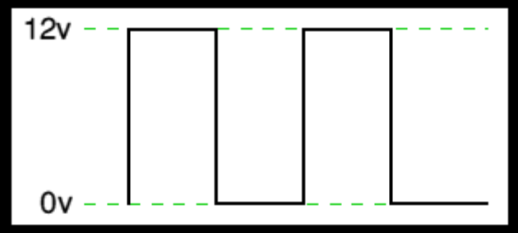
Fig 6.3 Output Voltage Waveform of PWM
Similarly, if the switches keep the voltage at 12 for 3 times as long as at 0v, the average will be 3/4 of 12v - or 9v, as shown below and if the output pulse of 12v lasts only 25% of the overall time.
By varying - or 'modulating' - the time that the output is at 12v (i.e. the width of the positive pulse) we can alter the average voltage. So we are doing 'pulse width modulation'. I said earlier that the output had to feed 'a suitable device'. A radio would not work from this: the radio would see 12v then 0v, and would probably not work properly. However a device such as a motor will respond to the average, so PWM is a natural for motor control.

6.4.1 Pulse Width Modulator
So, how do we generate a PWM waveform? It's actually very easy, there are circuits available in the TEC site. First you generate a triangle waveform as shown in the diagram below. You compare this with a d.c voltage, which you adjust to control the ratio of on to off time that you require. When the triangle is above the 'demand' voltage, the output goes high. When the triangle is below the demand voltage, the
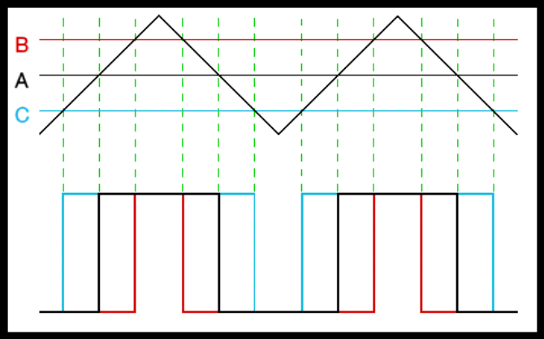
Fig 6.4 Triangular output Voltage
When the demand speed it in the middle (A) you get a 50:50 output, as in black. Half the time the output is high and half the time it is low. Fortunately, there is an IC (Integrated circuit) called a comparator: these come usually 4 sections in a single package. One can be used as the oscillator to produce the triangular waveform and another to do the comparing, so a complete oscillator and modulator can be done with half an IC and maybe 7 other bits.
The triangle waveform, which has approximately equal rise and fall slopes, is one of the commonest used, but you can use a saw tooth (where the voltage falls quickly and rinses slowly). You could use other waveforms and the exact linearity (how good the rise and fall are) is not too important.
Traditional solenoid driver electronics rely on linear control, which is the application of a constant voltage across a resistance to produce an output current that is directly proportional to the voltage. Feedback can be used to achieve an output that matches exactly the control signal. However, this scheme dissipates a lot of power as heat, and it is therefore very inefficient.
A more efficient technique employs pulse width modulation (PWM) to produce the constant current through the coil. A PWM signal is not constant. Rather, the signal is on for part of its period, and off for the rest. The duty cycle, D, refers to the percentage of the period for which the signal is on. The duty cycle can be anywhere from 0, the signal is always off, to 1, where the signal is constantly on. A 50% D results in a perfect square wave.

6.4.2 Why The PWM Frequency is Important
The PWM is a large amplitude digital signal that swings from one voltage extreme to the other. And, this wide voltage swing takes a lot of filtering to smooth out. When the PWM frequency is close to the frequency of the waveform that you are generating, then any PWM filter will also smooth out your generated waveform and drastically reduce its amplitude. So, a good rule of thumb is to keep the PWM frequency much higher than the frequency of any waveform you generate.
Finally, filtering pulses is not just about the pulse frequency but about the duty cycle and how much energy is in the pulse. The same filter will do better on a low or high duty cycle pulse compared to a 50% duty cycle pulse. Because the wider pulse has more time to integrate to a stable filter voltage and the smaller pulse has less time to disturb it the inspiration was a request to control the speed of a large positive displacement fuel pump. The pump was sized to allow full power of a boosted engine in excess of 600 Hp.
At idle or highway cruise, this same engine needs far less fuel yet the pump still normally supplies the same amount of fuel. As a result the fuel gets recycled back to the fuel tank, unnecessarily heating the fuel. This PWM controller circuit is intended to run the pump at a low speed setting during low power and allow full pump speed when needed at high engine power levels.

6.5 PWM Controller Features
This controller offers a basic “Hi Speed” and “Low Speed” setting and has the option to use a “Progressive” increase between Low and Hi speed. Low Speed is set with a trim pot inside the controller box. Normally when installing the controller, this speed will be set depending on the minimum speed/load needed for the motor. Normally the controller keeps the motor at this Lo Speed except when Progressive is used and when Hi Speed is commanded (see below). Low Speed can vary anywhere from 0% PWM to 100%.
Progressive control is commanded by a 0-5 volt input signal. This starts to increase PWM% from the low speed setting as the 0-5 volt signal climbs. This signal can be generated from a throttle position sensor, a Mass Air Flow sensor, a Manifold Absolute Pressure sensor or any other way the user wants to create a 0-5 volt signal. This function could be set to increase fuel pump power as turbo boost starts to climb (MAP sensor). Or, if controlling a water injection pump, Low Speed could be set at zero PWM% and as the TPS signal climbs it could increase PWM%, effectively increasing water flow to the engine as engine load increases.
This controller could even be used as a secondary injector driver (several injectors could be driven in a batch mode, hi impedance only), with Progressive control (0-100%) you could control their output for fuel or water with the 0-5 volt signal.
Progressive control adds enormous flexibility to the use of this controller. Hi Speed is that same as hard wiring the motor to a steady 12 volt DC source. The controller is providing 100% PWM, steady 12 volt DC power. Hi Speed is selected three different ways on this controller: 1) Hi Speed is automatically selected for about one second when power goes on. This gives the motor full torque at the start. If needed this time can be increased ( the value of C1 would need to be increased). 2) High Speed can also be selected by applying 12 volts to the High Speed signal wire. This gives Hi Speed regardless of the Progressive signal.
6.5.1 Sinusoidal Pulse Width Modulation
In many industrial applications, Sinusoidal Pulse Width Modulation (SPWM), also called Sine coded Pulse Width Modulation, is used to control the inverter output voltage. SPWM maintains good performance of the drive in the entire range of operation between zero and 78 percent of the value that would be reached by square-wave operation. If the modulation index exceeds this value, linear relationship between modulation index and output voltage is not maintained and the over-modulation methods are required

6.5.2 Space vector pulse width Modulation
A different approach to SPWM is based on the space vector representation of voltages in the d, q plane. The d, q components are found by Park transform, where the total power, as well as the impedance, remains unchanged.
Fig: space vector shows 8 space vectors in according to 8 switching positions of inverter, V* is the phase-to-center voltage which is obtained by proper selection of adjacent vectors V1 and V2.
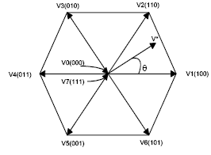
Fig 6.5 Inverter output voltage space vector
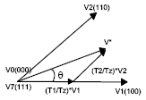
Fig 6.6 Determination of Switching times
The reference space vector V* is given by Equation (1), where T1, T2 are the intervals of application of vector V1 and V2 respectively, and zero vectors V0 and V7 are selected for T0.
V* Tz = V1 *T1 + V2 *T2 + V0 *(T0/2) + V7 *(T0/2)………. .………………...(1)
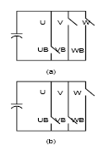
Fig 6.7 Inverter switching state for (a)V1, (b) V2
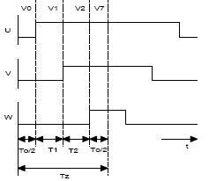
Fig 6.8 Pulse pattern of Space vector PWM

6.6 SVM PWM Technique
The Pulse Width modulation technique permits to obtain three phase system voltages, which can be applied to the controlled output. Space Vector Modulation (SVM) principle differs from other PWM processes in the fact that all three drive signals for the inverter will be created simultaneously. The implementation of SVM process in digital systems necessitates less operation time and also less program memory.
The SVM algorithm is based on the principle of the space vector u*, which describes all three output voltages ua, ub and uc :
u* = 2/3 . ( ua + a . ub + a2 . uc ) ……………………………….(2)
Where a = -1/2 + j . v3/2 We can distinguish six sectors limited by eight discrete vectors u0…u7 (fig:- inverter output voltage space vector), which correspond to the 23 = 8 possible switching states of the power switches of the inverter.
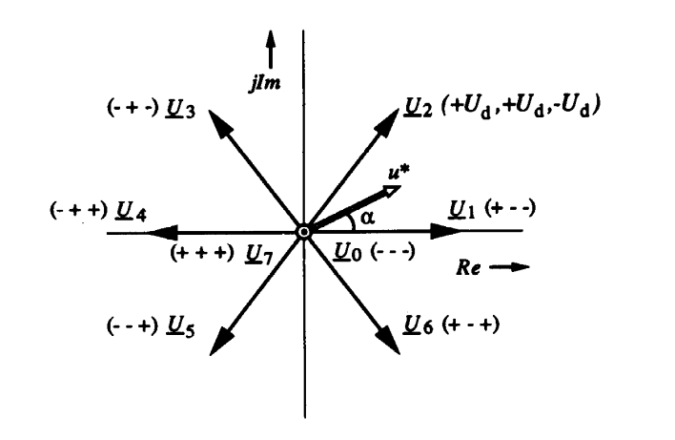
Fig 6.9 Space vector Modulation

The amplitude of u0 and u7 equals 0. The other vectors u1…u6 have the same amplitude and are 60 degrees shifted.
By varying the relative on-switching time Tc of the different vectors, the space vector u* and also the output voltages ua, ub and uc can be varied and is defined as:
ua = Re ( u* )
ub = Re ( u* . a-1)
uc = Re ( u* . a-2) …………………………………..(3)
During a switching period Tc and considering for example the first sector, the vectors u0, u1 and u2 will be switched on alternatively.
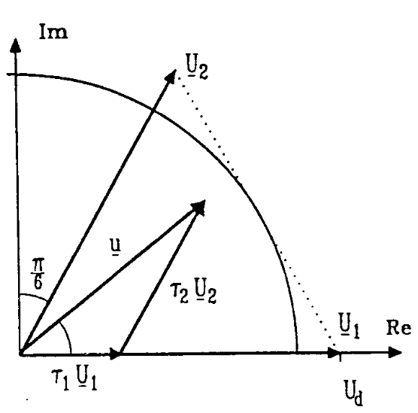
Fig 6.10 Switching states of SVM
Definition of the Space vector
Depending on the switching times t0, t1 and t2 the space vector u* is defined as:
u* = 1/Tc . ( t0 . u0 + t1 . u1 + t2 . u2 )
u* = t0 . u0 + t1 . u1 + t2 . u2
u* = t1 . u1 + t2 . u2 ……………………………….. (4)
Where
t0 + t1 + t2 = Tc and
t0 + t1 + t2 = 1
t0, t1 and t2 are the relative values of the on switching times.
They are defined as: t1 = m. cos (a + p/6)
t2 = m. sin a
t0 = 1 - t1 - t2

Their values are implemented in a table for a modulation factor m = 1. Then it will be easy to calculate the space vector u* and the output voltages ua, ub and uc. The voltage vector u* can be provided directly by the optimal vector control laws w1, v_{sa} and v_{sb}. In order to generate the phase voltages ua, ub and uc corresponding to the desired voltage vector u* the following SVM strategy is proposed.

6.7 Three Level Inverter Analysis
A three-level inverter to ascertain the differences between it and a conventional two-level inverter For a three-phase three-level inverter, a structure similar to that used with 12 electronic devices (IGBT) is needed (Fig. 1). Each phase will switch across three voltage levels (+V _{dc}/2, 0, and -V_{dc}/2). In a structure such as this the maximum voltage across the IGBT is limited to half the maximum dc link voltage (V_{dc}/2).
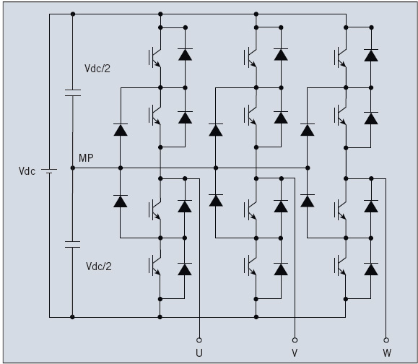
Fig 6.11 Three-phase three-level inverter topology

Three-phase two-level-inverter (PWM)-generation algorithms can also be applied to multilevel inverters. The algorithms with a triangular carrier waveform produce the best benefits in terms of harmonic distortion reduction, i.e. a three-level inverter needs both a carrier and a reference. In this case the number of triangular carriers is equal to L-1, where L is the number of voltage levels. For a three-phase three-level inverter this means that two triangular carriers and one sinusoidal reference are needed.
Three alternative PWM strategies with differing phase relationships can be used for a three-level inverter:
Alternative phase-opposition disposition (APOD), where carriers in adjacent bands are phase-shifted by 180°.
Phase-opposition dispositions (POD), where the carriers above the reference zero point are 180° out of phase with those below zero.
Phase disposition (PD), where all carriers are in phase across all bands.
PD strategy is used most frequently because it produces minimum harmonic distortion for the line-to-line output voltage. Triangular carriers and sinusoidal reference profiles, as well as IGBT and NCD current profiles, are shown in Fig.2

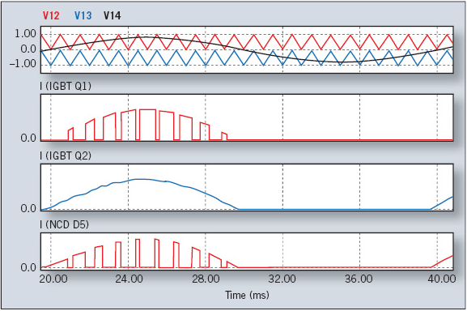
Fig 6.12 Phase disposition (PD) three-level inverter

A three-level inverter appears to comprise highly complex circuitry compared with a two-level inverter. The resulting technical and economic advantages, however, are the reasons why the use of three-level inverters is strongly recommended.
A three-level inverter features an IGBT with a lower reverse-blocking voltage: 600 V instead of 1,200 V. The 600-V chips are normally faster and thinner than 1,200-V chips. The silicon in a three-level inverter therefore has lower switching losses and a lower forward-voltage drop, the total losses per single arm of the three-level inverter are 60% lower than those of the two-level inverter. Q2 and Q3 switching losses are negligible. D1 and D4 diodes carry a very low current value since the current of Q1 commutes to D5; the current of Q4 commutes to D6, and the current of Q2 commutes to Q3. Clamp diodes carry the full load current.
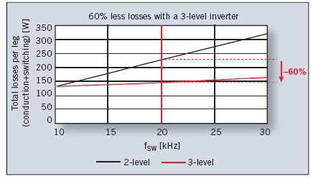
Fig.6.13 overall losses as a function of the switching frequency for a single inverter leg (3L vs.2L )

DISTRIBUTTION GENERATION SYSTEM
7.1 Introduction

Distributed Generation (DG) also called as site generation, dispersed generation, embedded generation, decentralized generation, decentralized energy or distributed energy, generates electricity from the many small energy sources. In recent years, micro electric power systems such as photovoltaic generation systems, wind generators and micro gas turbines, etc., have increased with the deregulation and liberalization of the power market. Under such circumstances the environment surrounding the electric power industry has become ever more complicated and provides high-quality power in a stable manner which becomes an important topic. Here DG is assumed to include Wind power Generation (WG) and Fuel Cells (FC), etc. Wind energy is the world‘s fastest-growing energy technology. It is a clean energy source that is reliable, efficient and reduces the cost of energy for homeowners, farmers and businesses. Wind turbines can be used to produce electricity for a single home or building, or they can be connected to an electricity grid for more widespread electricity distribution. They can even be combined with other renewable energy technologies. For utility-scale sources of wind energy, a large number of turbines are usually built close together to form a wind farm. Several electricity providers today use wind farms to supply power to their customers. Fuel cell systems have high energy efficiency. The efficiency of low temperature proton exchange membrane (PEM) fuel cells is around 35-45%. High temperature solid oxide fuel cells (SOFC) can have efficiency as high as 65%. The overall efficiency of an SOFC based combined-cycle system can even reach 70%. Renewable energy and fuel cell systems are environmentally friendly. From these systems, there is zero or low emission (of pollutant gases) that causes acid rain, urban smog and other health problems; and, therefore, there is no environmental cleanup or waste disposal cost associated with them. Why distributed generation (DG) system: The five major factors that contribute to the renewed interest in distributed generation (DG) system:

Alternative /Renewable powers have the following advantages: 1) Renewable energy resources are not only renewable, but also abundant: For example, according to the data of 2000, the U.S. wind resources can produce more electricity than the entire nation would use. The total solar energy from sun in a day at the earth surface is about 1000 times more than the all fossil fuels consumption. 2) Fuel cell systems have high energy efficiency: The efficiency of low temperature proton exchange membrane (PEM) fuel cells is around 35-45%. High temperature solid oxide fuel cells (SOFC) can have efficiency as high as 65%. The overall efficiency of an SOFC based combined-cycle system can even reach 70%. 3) Renewable energy and fuel cell systems are environmentally friendly: From these systems, there is zero or low emission (of pollutant gases) that causes acid rain, urban smog and other health problems; and, therefore, there is no environmental cleanup or waste disposal cost associated with them. 4) Different renewable energy sources can complement each other: Though renewable energy resources are not evenly distributed throughout the world, every region has some kinds of renewable
energy resources. At least, sunlight reaches every corner in the world. And different energy resources (such as solar and wind energy) can complement each other. This is important to improve energy security for a nation like the U.S. which is currently dependent on the foreign energy sources. These renewable/alternative power generation systems normally have modular structure and can be installed close to load centers as distributed generation sources (except large wind and PV farms). Therefore, no high voltage transmission lines are needed for them to supply electricity. In general, due to the ever increasing energy consumption, the rising public awareness for environmental protection, the exhausting density of fossil-fuel, and the intensive political and social concerns upon the nuclear power safety, alternative (i.e., renewable and fuel cell based) power generation systems have attracted increased interest.
7.2 Micro Grid

A micro grid is a localized grouping of electricity generation, energy storage, and loads that normally operates connected to a traditional centralized grid (macro grid). This single point of common coupling with the macro grid can be disconnected. The micro grid can then function autonomously. Generation and loads in a micro grid are usually interconnected at low voltage. From the point of view of the grid operator, a connected micro grid can be controlled as if it was one entity. Micro grid generation resources can include fuel cells, wind, solar, or other energy sources. The multiple dispersed generation sources and ability to isolate the micro grid from a larger network would provide highly reliable electric power. Byproduct heat from generation sources such as micro turbines could be used for local process heating or space heating, allowing flexible trade off between the needs for heat and electric power.

7.3 Modes of Power Generation

DER systems may include the following devices/technologies
- Combined heat power (CHP)
- Fuel cells
- Micro combined heat and power (MicroCHP)
- Micro turbines
- Photovoltaic Systems
- Reciprocating engines
- Small Wind power systems
- Stirling engines

Comparing with the nuclear energy and thermal power, the renewable energy is inexhaustible and has non-pollution characteristics. The solar energy, wind power, hydraulic power and tide energy are natural resources of the interest to generate electrical sources. Extensive and generalized usage of renewable energy is very popular to reduce the pollutions we have cause on earth. The wind and solar energy are welcome substitution for many other energy resources because it is natural, inexhaustible resource of sunlight to generate electricity The main disadvantage of wind turbines is that naturally variable wind speed causes voltage and power fluctuation problems at the load side. This problem can be solved by using appropriate power converters and control strategies. Another significant problem is to store the energy generated by wind turbines for future usage when no wind is available but the user demand exists The solar cell depends on the weather factors, mainly the irradiation and the cell temperature. Therefore, the weather factors such as the irradiation and the temperature are utilized for the estimation of the maximum power in this paper. After many technological advances, proton exchange membrane fuel cell technology has now reached the test and demonstration phase. The recent commercial availability of small PEMFC units has created many new opportunities to design hybrid energy systems for remote applications with energy storage in hydrogen form [2]. By using an electrolyzer, hydrogen conversion allows both storage and transportation of large amounts of power at much higher energy densities Furthermore, coupling a wind turbine, a solar cell, fuel cells and electrolyzers is efficacious to improve environment pollution because of by using natural In this paper, a detailed dynamic model and simulation of a solar cell/wind turbine/fuel cell hybrid power system is developed using a novel topology to complement each other and to alleviate the effects of environmental variations. Modeling and simulations are conducted using MATLAB/Simulink software packages to verify the effectiveness of the proposed system. The results show that the proposed hybrid power system an tolerate the rapid changes in natural conditions and suppress the effects of these fluctuations on the voltage within the acceptable range.

7.4 Why Distributed Generation (DG) System

The five major factors that contribute to the renewed interest in distributed generation (DG) system:

- Electricity market liberalization

- Developments in DG technologies

- Increased customer demand for highly reliable electricity.

- Environmental concerns.

- Constraints on the construction of new transmission lines

7.5 Advantages of DG Systems

Utility perspective

- On-site power supply avoids transmission and distribution losses.

- Increasing the efficiency compared with central power generation.

- Diversification of power sources.

- A possible solution to constraints on new transmission lines.

- Provides cleaner power by using renewable sources such as wind and sun.

- Better quality of power.

- Hedge against uncertain load growth and high market.

Customer perspective

- Improving energy efficiency and reducing green house- gas emission through combined heat and power (CHP) plants and renewable sources.

- Improved reliability by having back-up generation.

- Receiving compensation from the utility for making their generation capacity available to the power system in areas with power shortages.

Commercial power producer

- distributed generation systems with their comparatively small size and short lead times as well as their different technologies, allow players in electricity market to respond in a flexible way to changing market conditions.

- To sell ancillary services (such as reactive power and stand by capacity etc.

7.6 Why Alternative/renewable Energy?

The term ―alternative energy is referred to the energy produced in an environmentally friendly way (different from conventional means, i.e., through fossil-fuel power plants, nuclear power plants and hydropower plants). Alternative energy consideed in this dissertation is either renewable or with high energy conversion efficiency. There is a broad range of energy sources that can be classified as alternative energy such as solar, wind, hydrogen (fuel cell), biomass, and geothermal energy. Nevertheless, as mentioned in the previous section, at present the majority of the world electricity is still generated by fossil fuels, nuclear power and hydropower. However, due to the following problems/concerns for conventional energy 5 technologies, the renewable/alternative energy sources will play important roles in electricity generation. And, sooner or later, today‘s alternatives will become tomorrow‘s main sources for electricity.

Conventional generation technologies are not environment friendly

- Conventional energy sources are not renewable

- The cost of using fossil and nuclear fuels will go higher and higher

- Hydropower sources are not enough and the sites are normally far away from Load centers.

- Political and social concerns on safety are pushing nuclear power away.

PROPOSED SYSTEM
8.1 Introduction
The block diagram of proposed model system is shown in below fig.1. In this work the electric power qualities in two cases will be compared. Case I: With the storage battery when it is introduced. Case II: Without the storage battery. The storage battery executes the control that maintains the voltage in the power system. It will be found that the electric power quality will be improved, when storage battery is introduced. The proposed model system used in this work is composed of a Wind Turbine, an Induction Generator, Fuel Cells, An Inverter and a Storage Battery. A miniature Wind Power Generator is represented by WG. A fuel cell module is represented by FC. Transmission lines will be simulated by resistors and coils. The combined length of the lines from synchronous generator to the load terminal is 1.5 km. The electric power qualities in two cases will be compared. In first case with the storage battery when it is introduced and second case is without the storage battery. The storage battery executes the control that maintains the voltage in the power system. It will be found that the electric power quality will be improved, when storage battery is introduced. This model will be simulated using MATLAB/SIMULINK.
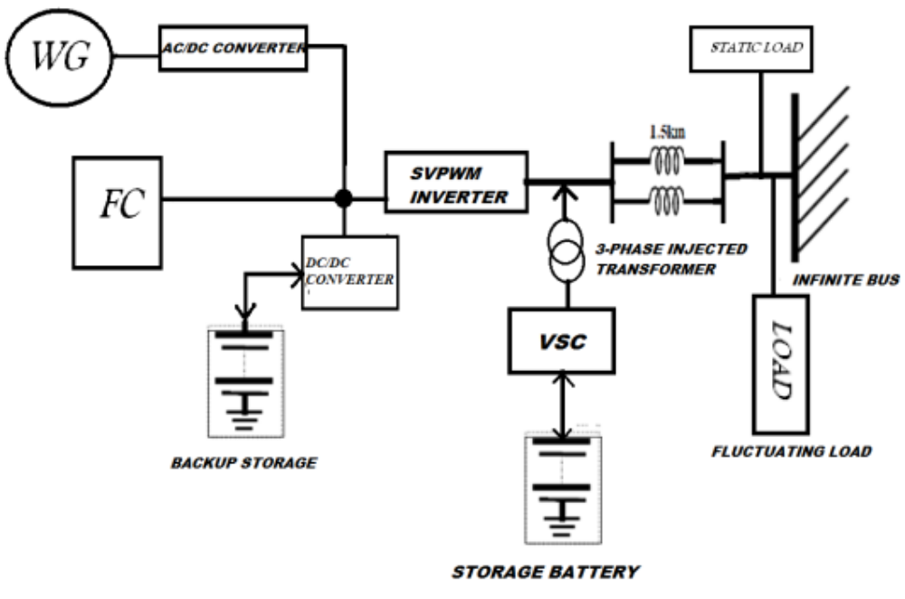
Fig 8.1 Diagram of proposed system

8.2 The Proposed System Consists of Following Main Sections

1. Wind Generator

A wind turbine and an induction generator is used as wind generator. It will convert the wind energy into electrical energy. The induction generator is the most common generator in wind energy system applications due to simplicity and rudeness, more than 50 years life time, same machine can be use as motor or generator without modification, high power unit mass of materials and flexibility in speed range of operation. The main drawbacks in induction generator are its lower efficiency and the need for reactive power to build up the terminal voltage. However the efficiency can be improved by modern design and solid-state converters can be used to supply reactive power required.
Induction generators are widely used in nonconventional power generation. Self-excited, squirrel cage induction generators are ideally suited for remote, stand-alone applications due to their robust construction. A new closed loop IGBT based PWM controller is proposed for a self-excited induction generator.

2. Fuel Cell Module

Fuel cell systems have high energy efficiency. The efficiency of low temperature proton exchange membrane (PEM) fuel cells is around 35-45%. High temperature solid oxide fuel cells (SOFC) can have efficiency as high as 65%. The overall efficiency of an SOFC based combined-cycle system can even reach 70%. Renewable energy and fuel cell systems are environmentally friendly. From these systems, there is zero or low emission (of pollutant gases) that causes acid rain, urban smog and other health problems; and, therefore, there is no environmental cleanup or waste disposal cost associated with them.

3. Energy Storage Unit

It is responsible for energy storage in DC form, flywheels, lead acid batteries, superconducting magnetic energy storage (SMES) and super-capacitors can be used as energy storage devices, the estimates of the typical energy efficiency of four energy storage technologies area: batteries 75%, Flywheel 80 %, Compressed air 80%, SMES 90%.

4. SVPWM Inverter

3-phase voltage source inverter (VSI) is used as inverter. It is used to convert from DC storage to ac by using svpwm technique. Single-phase VSIs cover low-range power applications and three-phase VSIs cover the medium- to high-power applications. The main purpose of these topologies is to provide a three-phase voltage source, where the amplitude, phase, and frequency of the voltages should always be controllable. Although most of the applications require sinusoidal voltage waveforms (e.g., ASDs, UPSs, FACTS, var compensators), arbitrary voltages are also required in some emerging applications (e.g., active filters, voltage compensators). The standard three-phase VSI topology is shown in Fig.2. and the eight valid switch states are given in Table.1. As in single-phase VSIs, the switches of any leg of the inverter (S1 and S4, S3 and S6, or S5 and S2) cannot be switched on simultaneously because this would result in a short circuit across the dc link voltage supply. Similarly, in order to avoid undefined states in the VSI, and thus undefined ac output line voltages, the switches of any leg of the inverter cannot be switched off simultaneously as this will result in voltages that will depend upon the respective line current polarity. Of the eight valid states, two of them (7 and 8 in Table.1) produce zero ac line voltages. In this case, the ac line currents freewheel through either the upper or lower components

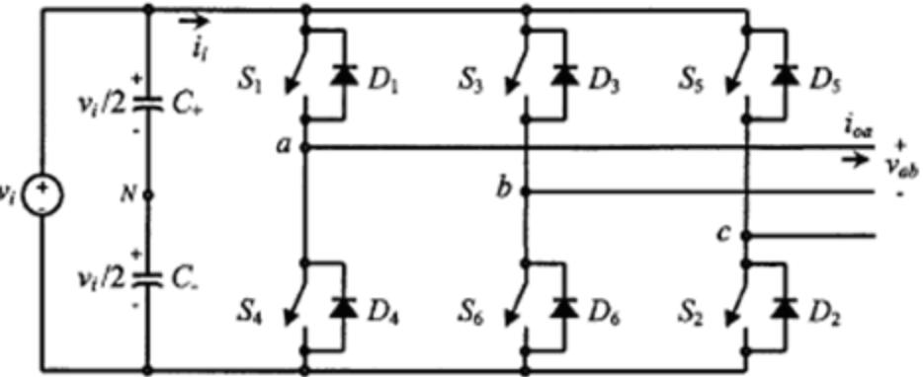

Fig 8.2 Three Phase VSI Topology

The remaining states (1 to 6 in Table.1) produce nonzero ac output voltages. In order to generate a given voltage waveform, the inverter moves from one state to another. Thus the resulting ac output line voltages consist of discrete values of voltages that are Vi , 0, and -Vi. The selection of the states in order to generate the given waveform is done by the modulating technique that should ensure the use of only the valid states.

Table 8.1 Valid switching states for three phase VSI
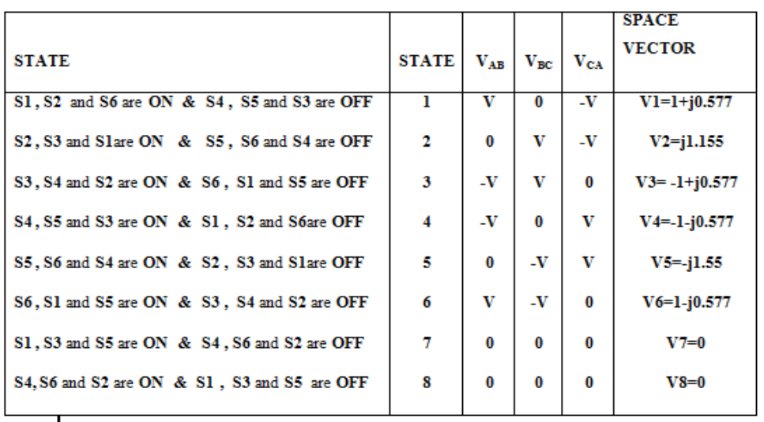

5. Voltage Source Converter (VSC)

It is used in storage system to inject the ac voltages during the stationery and transient distortions in the line voltage.

6. Dc/dc Converter

It is used to convert dc to dc storage.

7. Passive Filters

It is clear that higher order harmonic components distort the compensated output voltage. Filter is used to convert the PWM inverted pulse waveform into a sinusoidal waveform. This is achieved by removing the unnecessary higher order harmonic components generated from the DC to AC conversion in the VSI.

8. 3-phase Voltage Injection Transformers
In a three-phase system, three Single-phase transformer units or one three phase transformer unit can be used for voltage.

SIMULATION RESULTS
Case-1: Simulation Model of The Project Without Storage Battery
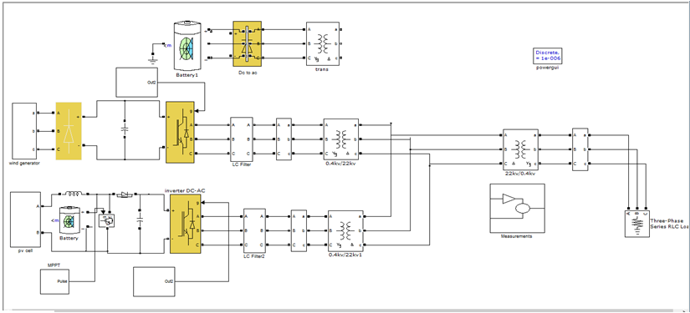
Fig 9.1 simulation diagram without storage battery

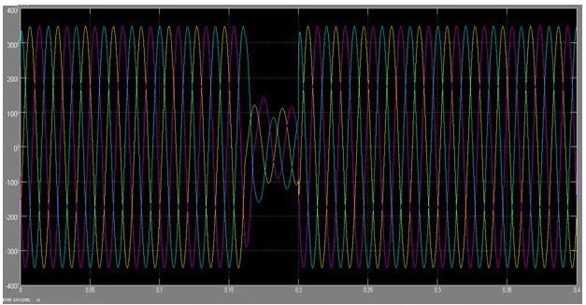
Fig 9.2 Out voltage waveform at time short duration transient 0.15sec to 0.2sec.duration

Case-2: Simulation Model of Project With Storage Battery
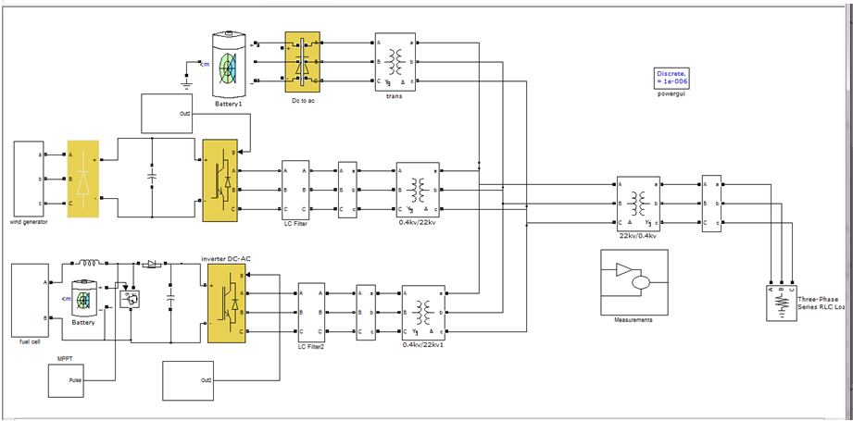
Fig 9.3 simulation diagram with storage battery

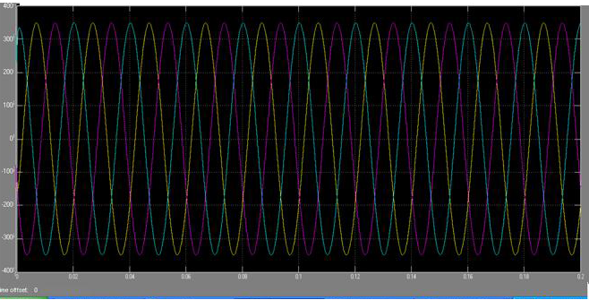
Fig 9.4 Output waveform of 3-phase load voltages when battery is introduced
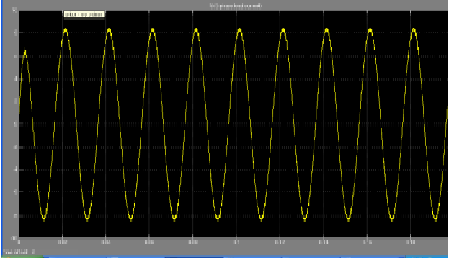

Fig 9.5 Output Waveforms of load current

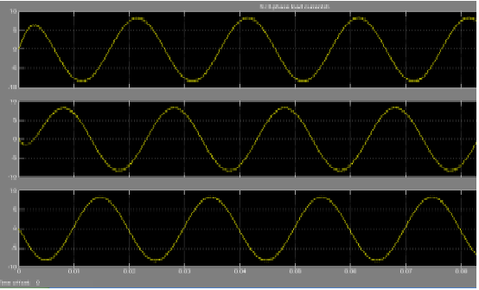
Fig 9.6 Output of three phase load currents

CONCLUSION
Based on the analysis of test system, it is suggested that voltage sag values are major factors in estimating the DC storage value. Investigations were carried out for various cases of load. The effectiveness of a proposed system mainly depends upon the rating of DC storage rating and the percentage voltage sag. In the test system it is observed that after a particular amount of voltage sag, the voltage level at the load terminal decreases. The major role play is that it can be supply constant power to varying loads, sag is reduced completely, THD of the system is very less. This scheme of implementation can be applied to various kinds of loads and systems in future.
By designing with the high Quality components and good controller the storage battery system can be integrated to the hybrid system to improve power quality which is not covered in this scope of project.
This scheme of implementation can also be applied higher ratings of power generation. The major role play is that it can be supply constant power to varying loads, sag is reduced completely, THD of the system is very less.
This scheme of implementation can be applied to various kinds of loads and systems in Future.

FUTURE SCOPE

- As Future scope of this Project is The storage Battery with good control Structure can be added to a DC bus of Hybrid Distributed Generation (DG) power system.

- By designing with the high Quality components and good controller the storage battery system can be integrated to the hybrid system to improve power quality which is not covered in this scope of project.

- This scheme of implementation can also be applied higher ratings of power generation.

- The major role play is that it can be supply constant power to varying loads, sag is reduced completely, THD of the system is very less.

- This scheme of implementation can be applied to various kinds of loads and systems in

REFERENCES
[1]. Ray Arnold “Solutions to Power Quality Problems” power engineering journal 2001

pages: 65-73.

[2]. John Stones and Alan Collinsion “Introduction to Power Quality” power engineering

journal 2001 pages: 58 -64.

[3]. Gregory F. Reed, Masatoshi Takeda, "Improved power quality solutions using

advanced solid-state switching and static compensation technologies," Power

Engineering Society 1999 Winter Meeting, IEEE.

[4]. S. W. Mohod and M. V. Aware, “Power quality issues & it’s mitigation technique in

wind energy conversion,” in Proc. of IEEE Int. Conf. Quality Power & Harmonic,

Wollongong, Australia, 2008.

[5]. Power quality improvement in electronic load controller for an isolated steam power

generation by Bhim Singh IEEE TRANSACTIONS ON ENERGY CONVERSION,

VOL. 23, NO.3, SEPTEMBER 2008.

[6]. B. Singh, “Induction generator—A prospective,” Electr Mach. Power Syst., vol. 23,

pp. 163–177,

[7]. R.C. Bansal, T.S. Bhatti, and D. P. Kothari, “Bibliography on the application of

induction generator in non conventional energy systems,” IEEE Trans. Energy

Convers., vol. EC-18, no. 3, pp. 433–439, Sep. 2003.

[8]. G. K. Singh, “Self-excited induction generator research—A survey,” Electr. Power Syst. Res., vol. 69, no. 2/3, pp. 107–114, May 2004.

[9]. R. C, “Three phase isolated asynchronous generators: An overview,” IEEE Trans.

Energy Convers., vol. 20, no. 2, pp. 292–299, Jun. 2005.

[10]. O. Ojo, O. Omozusi, and A. A. Jimoh, “The operation of an inverter assisted single

phase induction generator,” IEEE Trans. Ind. Electron., vol. 47, no. 3, pp. 632–640,
Jun. 2000.

[11]. Yazhou Lei; Mullane, A. Lightbody, G. Yacamini, R. ―Modeling of the Wind

Turbine with a Doubly Fed Induction generator for Grid Integration Studies‖, Dept

of Electr & Electron. Eng., Univ. Coll. Cork, Ireland, 21 February 2006, pp.257 –

264.

[12]. Ropp, M. Bansal.E. Gonzalez, S. ―Development of a MATLAB/Simulink Model

of a Single-Phase Grid-Connected Photovoltaic System‖, Dept of Electr. Eng., South

Dakota State Univ., Brookings, SD, February 2009, pp. 195 – 202.

[13]. J. Holtz, “Pulse width modulation for electronic power conversion,” Proc. IEEE,

vol. 82, pp. 1194–1214, Aug. 1994.

[14]. O. Ogasawara, H. Akagi, and A. Nabel, “A novel PWM scheme of voltage source

inverters based on Sspace vector theory,” in Proc. EPE European Conf. Power

Electronics and Applications, 1989, pp. 1197–1202.

[15]. M. Depenbrock, “Pulsewidth control of a 3-phase inverter with nonsinusoidal phase

voltages,” in Proc. IEEE-IAS Int. Semiconductor Power Conversion Conf., Orlando,

FL, 1975, pp. 389–398.

[16]. J. A. Houldsworth and D. A. Grant, “The use of harmonic distortion to increase the

output voltage of a three-phase PWM inverter,” IEEE Trans. Ind. Applicat., vol. 20,

pp. 1224– 1228, Sept./Oct. 1984.
[17]. Analysis, Simulation and Implementation of Space Vector Pulse Width Modulation

Inverter E Hendawi, F Khater, A Shaltout - Power, 2006 - wseas.us

